BUSINESS PLAN
Coffee Station

Submission Date: 2011. 12. 2
Major: Entrepreneurship
Student Number: 1110886
Student Name: Jieun Park

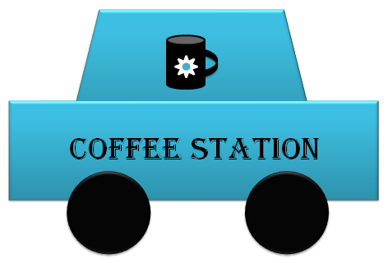
TABLE OF CONTENTS

A. EXECUTIVE SUMMARY
a. Brief Description of the Business
b. Method-How and Why I will succeed
B. BUSINESS DESCRIPTION
a. Vision and Objectives
b. Industry Trends
c. Organization and Ownership
C. THE MARKETING PLAN
a. Products Analysis
b. Market Analysis
c. Competitive Analysis
d. Location Analysis
e. Pricing Analysis
f. Marketing Strategies
D. THE OPERATIONS PLAN
E. THE FINANCIAL PLAN
a. Initial Investment
b. Income Statement
c. Cash Flow

A. EXECUTIVE SUMMARY
a. Brief Description of the Business
I will start-up a new business venture which is related with coffee. The brand name I made is “Coffee Station”. The reason why I made the brand name like Coffee Station is that I want to sell a coffee to people who are in the car. So, the places I want to start are where a lot of cars attending. Thus, I think it is unique because target and place appearance are different with other usual coffee shops.
-The brand logo

b. Method-How and Why I will succeed
As mentioned before, Coffee Station is very different with other usual coffee shops. People who do not want to come in the coffee shop can buy a coffee easily and they do not spend a lot of time because there is no need to get off the car. Also, People who are in the car but want to come inside the shop can buy a coffee too, because I will make a small coffee shop building contained Underground-Parking lot upside of the place for Coffee Station. It will be another different factor compared with other usual coffee shops because they do not have enough space for car or not at all. So, I can give a convenience to customers who are in the car. And the place appearance is similar with Gas Station so, it can give an ease of access to customers. Those are successful factors I think.
B. BUSINESS DESCRIPTION
a. Vision and Objectives
-Vision
I think about overall vision of what the business will look like once the company is fully developed.
“We will exist as necessary as real gas station”
People have to go to the gas station regularly if they do not want to go, but we are going to be a place they really want to visit.
-Objectives
1) Greater than 10% growth in earnings next year
2) After two years, Producing 20% products that did not exist this year
3) Making over 20 chain stores in two years

b. Industry Trends
First, I investigated the market of coffee in the United States. Because U.S is number one country in the coffee consumption. The first coffee in the U.S is instant coffee which is based on coffee bean by using coffee pot. Since then, according to life style, there is a development focused on the coffee which is based on an espresso and take-out culture. So, it spreads the culture that people around the world hold and drink coffee made by big brands and does a big role to routinize the coffee. That the U.S coffee market has already sparked a new wave which is called ‘Third Wave of Coffee’. And I searched about what ‘Third Wave of Coffee’ is. Characteristics of ‘Third Wave of Coffee’ are importing high quality beans from an origin, light roasting to do not burn the beans and finishing with latte art. They prefer high-quality coffees like single-origin coffee, drip coffee, and tea coffee and they put importance to natural taste of coffee. Coffee Consumers in the U.S say that dark roasting method of big franchise coffee shops is eating a tight burned beef. Thus, this ‘Third Wave of coffee’ does not stop at the U.S and will come soon moved to Korea. Because, Korea had been influenced by many significant parts of American culture. So, I think I have to meet this condition.

c. Organization and Ownership
-Organization
I want to make a Matrix Organization. Matrix Organization is an organizational structure that combines vertical and horizontal lines of authority, usually by superimposing product departmentalization on a functionally departmentalized organization.
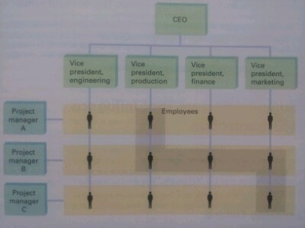
Source: Ricky W. Griffin, Management, 8th ed.
-Ownership
I want to choose a sole proprietorship. Because, it is the simplest and cheapest way to start a business. And, also I can have a pride of ownership and no special taxes. The following chart shows that relative percentage of sole proprietorships, partnerships, and corporations in the U.S. It means sole proprietorships, the most widespread form of business ownership, are most common in retailing and the service industries.

Source: U.S. Bureau of the Census, Statistical Abstract of the U.S. (www.census.gov)

C. THE MARKETING PLAN
a. Products Analysis
-Products Composition
Espresso | Ristretto | Extraction 20ml with 7g
Espresso | Solo | Extraction 30ml with 7g
Espresso | Double | Extraction 30ml with 14g
Espresso | Doppio | Extraction 60ml with 14g
Espresso | Lungo | Extraction 80ml with 7g
Americano |  | Espresso + Water
Tea coffee |  | Americano + Tea
Café latte |  | Espresso + Steamed milk
Cappuccino |  | Café latte + Milk foam
Café mocha |  | Espresso + Chocolate syrup + Steamed milk + Whipped cream
Caramel mocha |  | Espresso + Caramel syrup + Steamed milk + Whipped cream
Mocha latte |  | Café latte + Mocha syrup
Caramel Macchiato |  | Café latte + Caramel syrup

Those are the products I am going to sell to customers. Underlined products are main products. The reason why I focused on Espresso, Americano, Café latte, Cappuccino, and Tea coffee is that I want to follow the coffee trends which I mentioned at the above: Industry trends. I want to focus on the natural taste of coffee. So, I will income high quality of coffee beans which are from Arabica.
-Products Design (take-out)
 | Ounce | Volume | Diameter | Height
Paper cup | 10oz. | 300ml | 8.5cm | 10cm
Paper cup | 13oz. | 390ml | 8.5cm | 11.6cm
Paper cup | 16oz. | 480ml | 8.5cm | 13.4cm
Transparent cup | 10oz. | 300ml | 9.7cm | 9cm
Transparent cup | 14oz. | 420ml | 9.7cm | 10.3cm

b. Market Analysis
My market is a specific segment of the population, because I focused on people who have a car. To know the potential market size, I searched the Current station of license holders.
Gender | 2007 | 2008 | 2009 | 2010
Total (People) | 24,681,440 | 25,268,379 | 25,822,149 | 26,402,364
Men (people) | 15,248,126 | 15,554,394 | 15,817,223 | 16,074,165
Women (people) | 9,433,314 | 9,713,985 | 10,004,926 | 10,328,199
Retention (%) | 50.9 (%) | 52.0 (%) | 52.9 (%) | 54.5 (%)
Source: Korean Statistical Information Service
In the above chart, we can know that license holders are increasing annually and it means potential market size will be much bigger and bigger.

There are four kinds of the car: Passenger car, van, truck, and special car. But I think our main customers will be the people who have passenger car and van. So, I searched again by focusing on passenger car and van. The following chart is the data in 2010.
Passenger car |  |  |  | Van
Total | Official car | Private car | Business car | Total | Official car | Private car | Business car
13,631,769 | 22,872 | 13,124,972 | 483,925 | 1,049,725 | 15,039 | 931,740 | 102,946
Source: Korean Statistical Information Service
Thus, I assume my potential market size will be over than 14,681,494. Because, the number of car is increasing every year.

c. Competitive Analysis
Nowadays, many gas stations have coffee shop, convenience store, and pizza store etc. Because they think they can’t get enough profitability from only oil sales. I investigated about one of them.
*SK giryong gas station & egro coffee
One of the SK gas station is located at giryong and they changed original gas station into eco-friendly self-service gas station. People easily think gas station is little scary at night and has oily smell. But, they make a clean surrounding and egro coffee shop which is coffee professional brand of Swiss. So, the customers who do refuel can enjoy a coffee.
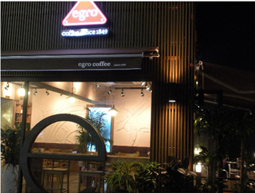
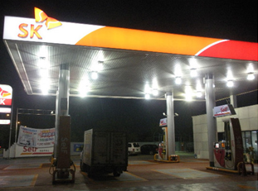

Source: http://blog.naver.com/PostView.nhn?blogId=suwonnaeil&logNo=130020489
I figured out their problem. First, they have a coffee shop but do not have an appropriate space for parking lot. Second, Customers have to get off the car to buy a coffee.

d. Location Analysis
First, I consider recognition and a lot of cars attending of the place. Because, my business is start-up business and we focus on the people who have a car. Gangnam is too expensive to me, so I choose Gangbuk Eunpyeong-gu or Gyeonggi-do Yeongtong-gu. Those areas have good public transportation. Visibility and electric capacity do not have a problem. But, I guess expansion of space might be difficult.
e. Pricing Scheme
Firstly, I search about original price of coffee bean. Price of coffee bean in one cup of coffee is 150won. But, Americano of many big coffee shop brands is about 4000won. It means they are selling to about 24~26times the price. They said the reason why price is expensive is because of the labor costs, store rental costs, and store management costs. But, Lotteria who uses same Arabica coffee bean with Angel-in-us sells Americano to 2000won. So, I will sell Americano 3000won.
-Coffee menu
Espresso | Ristretto | 2500won
Espresso | Solo | 2500won
Espresso | Double | 3000won
Espresso | Doppio | 3000won
Espresso | Lungo | 2500won
Americano |  | 3000won
Tea coffee |  | 3300won
Café latte |  | 3500won
Cappuccino |  | 3500won
Café mocha |  | 3700won
Caramel mocha |  | 3700won
Mocha latte |  | 3700won
Caramel Macchiato |  | 3700won

-Ristretto, Solo, Double, Doppio, Lungo use half amount of coffee beans, so I sharpen the price.
-Tea is added to Tea coffee, so I increase the price.
-Café latte and Cappuccino are used with milk, so I increase the price.
-Café mocha, Caramel mocha, Mocha latte, and Caramel Macchiato are used with syrup or whipped cream, so I increase the price.

f. Marketing Strategies
-Advertising: Being put in the magazine, Uploading online banner
-Sales Promotion: Membership Discount System- people who come first will receive a sticker card. Whenever they come, they can get a one sticker. If they collect 10stickers, they can get a Membership card which can get a 5% discount every time.
-Direct Marketing: Sending a catalog or pamphlet.

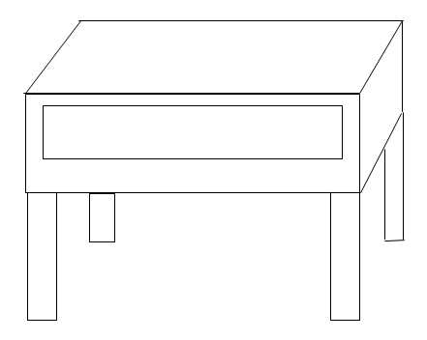
D. THE OPERATIONS PLAN
This picture is store I want to do a business. We can see this type of building to make a parking lot space on the ground. But, I will put two booths on the ground to get an order from customers who are in the car. And, the second floor is the inner coffee shop for the customers who want to come in. They can park a car to the underground parking lot.

E. THE FINANCIAL PLAN
a. Initial Investment
-monetary unit: won
 |  | Initial Startup Costs
Working Capital:
 | Cash | 5,000,000
Other Assets:
 | Marketing costs | 210,000
Fixed Assets:
 | Calculating computer system machine(3) | 2,500,000
 | Store Equipment | 20,000,000
 | Interior | 6,000,000
 | Office space: monthly rent | 8,000,000
 | Office space: deposit | 200,000,000
 | Refrigerator(2)-Big size | 2,000,000
 | Other | 0
 | Fixed Asset Subtotal = | 238,500,000
 | TOTAL = | 243,710,000

Marketing costs- Online banner system 10,000won in one month (www.adlocal.co.kr)
- Pamphlet costs: 3000pieces with 200,000won
Store Equipment- coffee machines, tables, chairs etc.
Interior- wallpapers, lights etc.
Office space- about 40pyeong

b. Income Statement
-monetary unit: won
 |  |  | Pro Forma Income Statement
 | Sales Revenue |  |  | 244,000,000
 | Other Income |  |  | -
 | Total Income |  |  | 244,000,000
 | Less:
 |  | Operating Expenses:
 |  |  | Supplier payments | 61,000,000
 |  |  | Electric bill | 13,450,000
 |  |  | Water bill | 6,650,000
 |  | Salaries: |  | 46,800,000
 |  | Traninig costs: |  | 2,400,000
 |  | Other Expenses: |  | 2,640,000
 |  |  | Advertising
 |  |  | Employee Insurance
 |  | Capital expenditure |  | 3,600,000
 |  | Office space-montly rent |  | 96,000,000
 | Total Expenses |  |  | 232,540,000
 | Earnings before taxes |  |  | 11,460,000
 | Taxes |  | 20% | 2,292,000
 | Net Income |  |  | 9,168,000
 | Dividends |  |  | -
 | Additions to Retained Earnings |  |  | 9,168,000
 | Number of Shares Outstanding |  |  | 3,300
 | Earnings Per Share |  |  | 2,778

c. Cash Flow
-monetary unit: won
Sources of funds | Month 1 | Month 2 | Month 3 | Month 4 | Month 5 | Month 6 | Month 7
Customer payments | 7,000,000 | 8,000,000 | 9,000,000 | 10,000,000 | 15,000,000 | 20,000,000 | 25,000,000
Owner's capital | 0 | 0 | 0 | 0 | 0 | 0 | 0
Total inflow | 7,000,000 | 8,000,000 | 9,000,000 | 10,000,000 | 15,000,000 | 20,000,000 | 25,000,000
Uses of funds | Month 1 | Month 2 | Month 3 | Month 4 | Month 5 | Month 6 | Month 7
Supplier payments | 2,000,000 | 2,500,000 | 3,000,000 | 3,500,000 | 4,000,000 | 5,000,000 | 6,000,000
Electric bill | 700,000 | 750,000 | 800,000 | 850,000 | 900,000 | 950,000 | 1,000,000
Water bill | 300,000 | 350,000 | 400,000 | 450,000 | 500,000 | 550,000 | 600,000
Salaries | 3,900,000 | 3,900,000 | 3,900,000 | 3,900,000 | 3,900,000 | 3,900,000 | 3,900,000
Training costs | 200,000 | 200,000 | 200,000 | 200,000 | 200,000 | 200,000 | 200,000
Other expenses | 220,000 | 220,000 | 220,000 | 220,000 | 220,000 | 220,000 | 220,000
Capital expenditures | 300,000 | 300,000 | 300,000 | 300,000 | 300,000 | 300,000 | 300,000
Office space-monthly rent | 8,000,000 | 8,000,000 | 8,000,000 | 8,000,000 | 8,000,000 | 8,000,000 | 8,000,000
Total outflow | 15,620,000 | 16,220,000 | 16,820,000 | 17,420,000 | 18,020,000 | 19,120,000 | 20,220,000
Opening bal. | 0 | -8,620,000 | -16,840,000 | -24,660,000 | -32,080,000 | -35,100,000 | -34,220,000
Net flow | -8,620,000 | -8,220,000 | -7,820,000 | -7,420,000 | -3,020,000 | 880,000 | 4,780,000
Closing bal. | -8,620,000 | -16,840,000 | -24,660,000 | -32,080,000 | -35,100,000 | -34,220,000 | -29,440,000

Sources of funds | Month 8 | Month 9 | Month 10 | Month 11 | Month 12 | Total
Customer payments | 30,000,000 | 30,000,000 | 30,000,000 | 30,000,000 | 30,000,000 | 244,000,000
Owner's capital | 0 | 0 | 0 | 0 | 0 | 0
Total inflow | 30,000,000 | 30,000,000 | 30,000,000 | 30,000,000 | 30,000,000 | 244,000,000
Uses of funds | Month 8 | Month 9 | Month 10 | Month 11 | Month 12 | Total
Supplier payments | 7,000,000 | 7,000,000 | 7,000,000 | 7,000,000 | 7,000,000 | 61,000,000
Electric bill | 1,500,000 | 1,500,000 | 1,500,000 | 1,500,000 | 1,500,000 | 13,450,000
Water bill | 700,000 | 700,000 | 700,000 | 700,000 | 700,000 | 6,650,000
Salaries | 3,900,000 | 3,900,000 | 3,900,000 | 3,900,000 | 3,900,000 | 46,800,000
Training costs | 200,000 | 200,000 | 200,000 | 200,000 | 200,000 | 2,400,000
Other expenses | 220,000 | 220,000 | 220,000 | 220,000 | 220,000 | 2,640,000
Capital expenditures | 300,000 | 300,000 | 300,000 | 300,000 | 300,000 | 3,600,000
Office space-monthly rent | 8,000,000 | 8,000,000 | 8,000,000 | 8,000,000 | 8,000,000 | 96,000,000
Total outflow | 21,820,000 | 21,820,000 | 21,820,000 | 21,820,000 | 21,820,000 | 136,540,000
Opening bal. | -29,440,000 | -21,260,000 | -13,080,000 | -4,900,000 | 3,280,000
Net flow | 8,180,000 | 8,180,000 | 8,180,000 | 8,180,000 | 8,180,000 | 107,460,000
Closing bal. | -21,260,000 | -13,080,000 | -4,900,000 | 3,280,000 | 11,460,000

